Tushar Ashok Naik 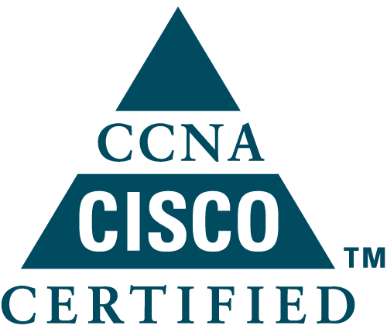
Shraddha aprartment c/5,01,sec-25 Juinagar-400706.
Mobile: +91 9594475100,9594678801
E-Mail:tushar14029@gmail.com

SUMMARY
- A dynamic professional with CCNA, over 61 Months of extensive experience in Network Management & Support.
- Currently working with TATA CONSULTANCY SERVICES (TCS) As Network Engineer.
- Successfully manages & delivers Network / Infrastructure/ for various clients.
- Effectively analyzes information system needs, evaluates end-user requirements and custom designing network solutions and troubleshoots complex information systems management.
- An effective communicator with honed relationship management, analytical, problem-solving skills.

DOMAIN SKILLS

Technologies

Routing | Eigrp,OSPF and PFR
Switching | VLAN, DVLAN, VTP, STP, HSRP, VRRP, VSS, Ether Channel, SNMP and SYSLOG
Security | SSL-VPN, Site to Site VPN, Firewall

Devices Handled

CISCO Routers | 1941, 2800, 3800, 7200
CISCO Switches | 2960, 3550, 3560, 3750, 4500, 6500 and Nexus 7000
Juniper | 8208, 4200, 3200
Firewalls | ASA-5510, 5520, Checkpoint-R71, R75, Juniper-SSG1000, SSG500,SRX 550.
Proxy | Websense
Load Balancer | RADWARE,F5 Big IP
WAN Optimizer | Riverbed Steelhead
Authentication | CISCO ACS, Juniper UAC
Monitoring Tools:

- SolarWinds NMS,
- Whatsup Gold Netflow analyzer
- Whatsup Gold SYSLOG Analyzer

CERTIFICATION

- Cisco Certified Network Associate (CCNA)
- Pursing Cisco ASA Certification
- Pursing checkpoint CCSA certification
- ITIL Certificatified

ACADEMIC QUALIFICATION

- Bachelor of Engineering in Electronics and Communications from Pune University Passed with First Class in May 2010.

PROFESSIONAL PROFILE

Working as System Engineer in TCS from Sep 2014 to Till Date.

Key Deliverables:

Project 2:- Client onsite- location Shrajah

Profile—Network Security Transition Engineer

- Maintenance of Networks devices like switch, Router,Load Balancer and firewall.
- Work on Cisco ASA firewall,juiniper firewall
- Working on Checkpoint Gaia, policy creation and troubleshooting
- Working on Big IP F5 upgradation and backup .
- Installation of SSL Certificate in F5.
- Creation of Members pool virtual.
- Troubleshooting on F5,redundency for virtual servers.

Project -1 US client 1year 3 mnonths

- Maintenance of Networks devices like switch, Router,Load Balancer and firewall.
- Working on Checkpoint Gaia, policy creation and troubleshooting
- Working on Big IP F5 upgradation and backup .
- Installation of SSL Certificate in F5.
- Creation of Members pool virtual.
- Troubleshooting on F5,redundency for virtual servers.
- Work on LTM and GTM of Big IP F5.
- Troubleshooting Network Related issue.
- Involved in Implementation of redundant & fail over links to maintain 100% uptime & 99.9% SLA

Work as Network Engineer in 3I InfoTech (CRISIL ltd) from Sep 2012 to Till Sep 2014.

Key Deliverables:

- Maintenance of Networks using Cisco Switches ~ [ 2900, 3500, 3750,4500 and 6500 Series],Routers ~ [Router 1800,3800 and 7200]
- Configuration of Switches & Maintenance of WAN & LAN.
- Effectively Implemented DVLAN using CISCO ACS.
- Efficiently configured PFR over Internet and MPLS links using APNIC IP.
- Coordination with ISPs to commission New links.
- Hands on Experience on Checkpoint, ASA and Juniper Firewalls.
- Configuration of IPSEC site-to-site VPN on checkpoint, ASA and Juniper.
- Configuration of Aventail and CISCO ASA SSL VPN.
- Effectively implemented Websense Proxy Device across all Global Locations.
- Effectively handled Multi vendor products.
- Hands on Experience on Netformx Design Expert Tool
- Preparing Technical Documentation of projects, Network Architecture diagrams, Network Inventory and SOP of different products using MS Office and MS Visio.
- Generation of network and service performance reports and addressing various issues Daily
- Managing Cisco Internetwork such as Backup, recovery and Up gradation of Cisco IOS and Configurations.
- Following ITIL process and involved in the incident , problem ,Change , Configuration mangement
- Involved in Implementation of redundant & fail over links to maintain 100% uptime & 99.9% SLA.
- Managing , Monitoring & Troubleshooting of all Leased line which spread across 40 locations throught world.
- Involved in the implementation of New Data centers.

Work as Network Engineer in The Oberoi from Dec 2010 to Feb 2012.

Key Deliverables:

- Maintenance of Networks using Cisco Switches ~ [ 2900,3500,4500 and 6500 Series],Routers [1800,3800 and 7200]
- Configuration of Switches & Maintenance of WAN & LAN.
- Coordination with ISPs to commission New links.
- Avaya VOIP phone configuration.
- Preparing Checking the Bandwidth of link and sending the MRTG,PRTG Report.
- Maintaining blackberry enterprise server like User Add, delete and edit profile
- Preparing Technical Documentation of projects, Network Architecture diagrams, Network Inventory and SOP of different products using MS Office and MS Visio.
- Generation of network and service performance reports and addressing various issues Dialy
- Managing Cisco Internetwork such as Backup, recovery and Up gradation of Cisco IOS and Configurations.
- Following ITIL process and involved in the incident , problem ,Change , Configuration management
- Involved in Implementation of redundant & fail over links to maintain 100% uptime & 99.9% SLA.
- Managing , Monitoring & Troubleshooting of all Leased line which spread across 40 locations throught world.
- Involved in the implementation of New Data centers.

PERSONAL DETAILS

Date of Birth : 2nd May, 1988.
Languages Known : English, Hindi, Marathi, Konkani
Marital Status : Single

PASSPORT DETAILS

Passport Number : K4314396
Name as in Passport : TUSHAR ASHOK NAIK.
Place of Issue : Navi mumbai.
Date of Issue : 08/06/2012.
Date of Expiry : 07/06/2022.

